PROJECT FINAL REPORT

“Binary Bazaar”

Online Marketplace

INFO 2413 S10

System Development Project

April 6, 2017

Submitted By:

William Corcoran

Lucas Magnien

Nirosh Ratnam

Yu-Tang Yu

Submitted To:

Mehdi Talwerdi

Office G2060

Kwantlen Polytechnic University

Table of Contents

**Project Definition and Description** 3

**Research and Study, Links** 3

**Plan for Implementation** 4

**Gantt Chart** 5

**ER and Database Schematic** 6

**How To Use the Application** 6

**Obstacles** 6

**Risk Assessments** 6

**Conclusion** 7

**Project Definition and Description**

For our project, our intention was to design and build an online store application (cloud SAAS) providing online POS for customers of client businesses, including as stretch goals, collation of shopping information for business statistical analysis, and the creation of financial statements based on collated information. The long-range focus of the project would be to provide exposure and feedback for business startups with new business identities and products as quickly and easily as possible, within a community setting.

An important aspect of this concept is ease-of-use, facilitating the rapid development of new identities and the introduction of new products to the marketplace community. This would provide new businesses with the fastest and easiest “proof-of-concept” possible. The final application includes a web-based service with attached database to facilitate the marketplace. Comprehensive client and customer portals are developed to provide access to services, eventually including access to social aspects and analytics.

**Research and Study, Links**

Many online materials were referenced and utilized for the proper implementation of the technologies used during the development of this project. The following is a list of some of the most notable:

**W3Schools**. A popular web site (run by a Norwegian group) providing complete references to web technologies, including HTML, CSS, JavaScript, Bootstrap, and jQuery, among others. <https://www.w3schools.com>

**jQuery Learning Center**. Comprehensive guide to using this JavaScript library for client-side scripting, for UI effects. <http://learn.jquery.com>

**GitHub Desktop User Guides**. GitHub was used as our main code and documentation repository. Access was possible via web services, and also through desktop client apps, such as GitHub Desktop. <https://help.github.com/desktop/guides/>

**GitKraken Support**. Another GitHub client app. <https://support.gitkraken.com>

**Slack**. Slack is a cloud-based team communication tool that allows real time chat over multiple channels. This tool was used during remote group developmental sessions, and general updates and situational awareness. <https://slack.com>

**Sublime Text 3 Documentation**. Sublime was used as our primary source code editor. It is designed to natively support many programming languages, such as HTML, CSS, JavaScript, and SQL. <http://www.sublimetext.com/docs/3/>

**Kong Documentation**. Kong was used as an API layer residing between web servers and database implementation. <https://getkong.org/docs/>

**MongoDB Documentation**. MongoDB is a document based database used in the backend of Binary Bazaar. <https://docs.mongodb.com/?_ga=1.143132085.1064778195.1491406684>

**Plan for Implementation**

**Architecture**. Several application tiers were required for the project:

At the front end, the customer and client web interfaces are made available by servers using Nginx web server, where HTML, CSS and JS web application archives are stored. The tables and data are implemented using the open source MongoDB on separate servers. In between the DB and web servers are machines running Kong, an open source API gateway and manager geared for RESTful Nginx web services. All tiers are to be implemented on Amazon Web Services cloud (PaaS). Please refer to the following diagram for a graphical representation of this design framework:

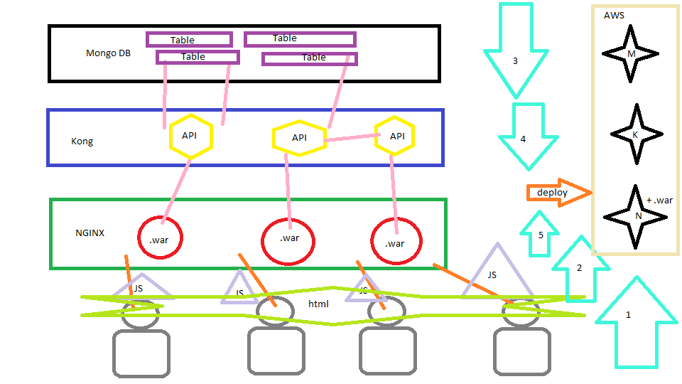

**User Interfaces**.

The following are screenshots and descriptions of all client and customer user interfaces:

**Gantt Chart**

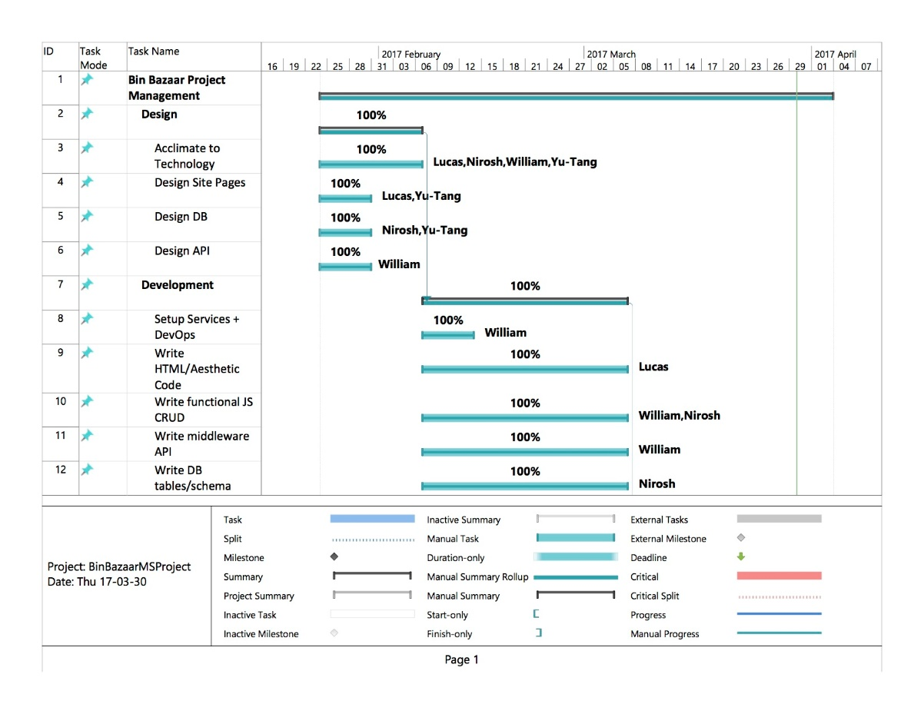

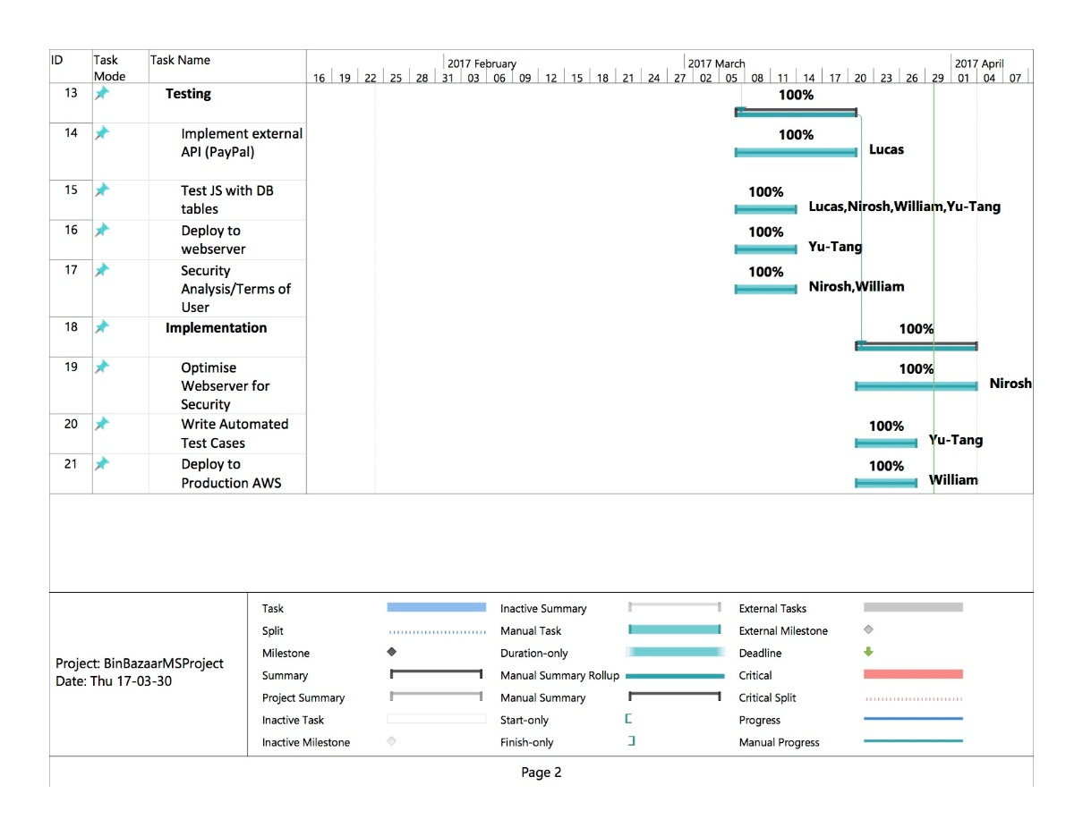

**ER and Database Schematic**

**How To Use the Application**

**Obstacles**

**Risk Assessments**

During the initial planning phase of the project, and throughout its early development, several potential pitfalls were considered, and possible approaches that could mitigate them. The following is a description of these considerations, in addition to a general outline of our design philosophies:

First, the skill levels of the different group members, with regards to the varied tasks that were required (such as web development, database and API design), was quite diverse, and considerable personal study and research was required to approach these tasks. The developmental approach we decided was best suited to these circumstances was a modular approach, in which each phase of early development was attempted by all group members. This enabled a more complete understanding of each facet of the application for every group member, and still allowed for successive task load balancing between group members for later iterations.

With regards to technology, the creation of features was scheduled more on an “as-needed” basis, meaning that the most important work was completed first, and further refinement was planned for future iterations. In theory, this would allow us to find out what technologies work early enough to still have time to change strategy or technology as development progressed.

**Conclusion**

Throughout the academic careers of our group’s members, numerous development technologies have been studied and implemented, but mostly in isolated case studies, and rarely in combination with one another. Understanding how these technologies can be integrated to work together as the various components of a whole application could only be achieved through experience.

Additionally, learning to cope with the numerous potential pitfalls of software development, ranging from human resources and communications issues to aspects of the utilized technologies and beyond, is a purely empirical undertaking. For these reasons, the development of Binary Bazaar, from conception to the form it finally took, has been extremely educational and rewarding. We feel the final deliverable project has real potential utility, and could be further developed in a real world environment, to suit the needs of actual client and customer users.